| Test 1 — Outline (Revised 1/20/20) | |
| --- | --- |
| Course Information: Phys 2B | Instructor Name: John R. Walkup |

### Equations Provided

(I will include the list of equations in the next outline update.)

### All questions are multiple choice – be sure to bring a Scantron.

#### Conceptual questions

1. A charge will travel through an electric field. You will indicate that you know what happens to the potential energy, kinetic energy, and total energy of the electron as it does so.

Opposites attract. Like forces repel. Electric potential energy is the energy that is needed to move a charge against an electric field.

You take the positive particle, and start to pull it off the plate, against the pull of the electric field. It’s hard work, because the electric force is pulling them together. If you let the positive particle go, it would snap back to the negative plate, pulled by the electric force. The energy that you used to move the particle away from the plate is stored in the particle as electrical potential energy. It is the potential that the particle has to move when it’s let go.

1. Watch the video titled “Electrostatic Induction” on Canvas. Be prepared for a multiple-choice question. If you watch the video and understand it, you should be okay.

<https://youtu.be/dwJ-MM7yu4E>

1. Watch the video titled “Inductive Charging using an Electroscope” on Canvas. If you watch the video and understand it, you should be okay.

<https://youtu.be/-JsVZwc1dOo>

1. I will provide a triboelectric series chart. After rubbing two materials together, you will tell me what happens to the net charge on each material according to the chart. See the image titled “Tribolelectric Series” on Canvas and read the accompanying explanation.

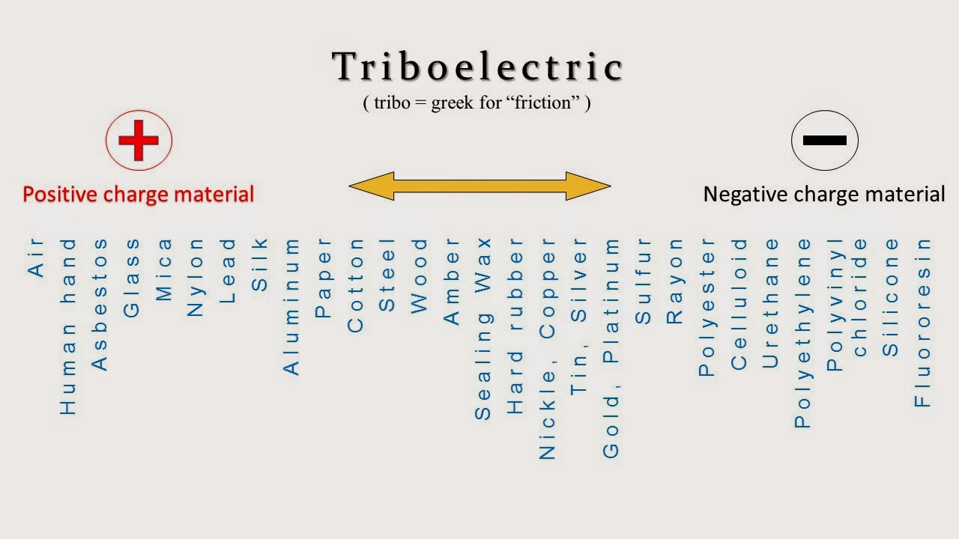

1. Understand the purpose of an electric field and how its value depend on the amount of charge and the distance between the charge and the point in space.

The electric field allows us to easily see how the general area around a point charge is charged, and how strong the charge is.

Electric field, an electric property associated with each point in space when charge is present in any form. The magnitude and direction of the electric field are expressed by the value of E, called electric field strength or electric field intensity or simply the electric field. Knowledge of the value of the electric field at a point, without any specific knowledge of what produced the field, is all that is needed to determine what will happen to electric charges close to that particular point.

1. Know what happens to the energy of a charge as it travels through a constant electric field.

If a charge is moving in the direction that it would normally move, its electric potential energy is decreasing. If a charge is moved in a direction opposite to that of it would normally move, its electric potential energy is increasing. This situation is similar to that of constant gravitational field (g = 9,8 m/s2).

1. It is not safe to stand near a tree during a lightning storm, however it is relatively safe to be inside a car. Know why.

protection is attributable to a so called "Faraday shield" due to the metal in the body of the car. Accordingly, a motorcycle offers no protection from lightning.

1. Problem 1 – 4 from Assignment “Basic Charge and Coulomb’s Law”

1. Problem 9 – 11 from Assignment “Basic Charge and Coulomb’s Law”

1. Problem 4 or 9 from Assignment “Coulomb’s Law and E Fields”

1. Problem 2, 3 or 12 from “Coulomb’s Law and E Fields”
2. Problem 3, 4, or 5 from “Potential and Potential Energy”
3. Wild card
4. Wild card

#### Computations

1. I will place two charges at a particular location in space. At another point in space, which we will call Point A, you will compute the net electric field (including direction) and potential.